* Scroll below for product specific size chart.

**Size options:**

* 4 years old
* 6 years old
* 8 years old
* 10 years old
* 12 years old
* 14 years old

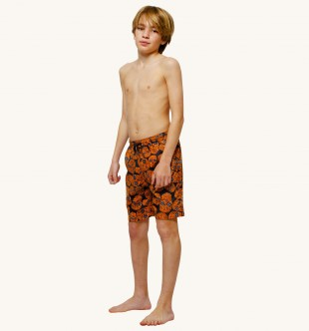**Skull Print Swimming Trunks**

**Materials, Care & Information:**

* Shorts: 100% Polyamide
* Mesh Lining: 50% Cotton and 50% Polyester
* Machine washable 30 degrees

## Description:

* From FRIAS, these vibrant swimming trunks with a three pocket design feature an all over red and black skull print, elasticated drawstring waist and branding to the back of the waistline.
* Sold with a navy drawstring pouch, they are sure to be a holiday essential this season.

## Cost: SGD 39.90

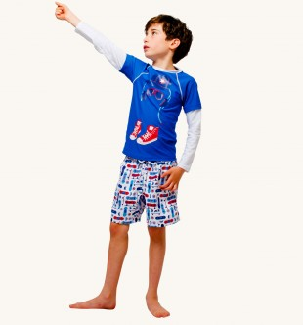

**Hip-hop Long Sleeve Shirt**

**Materials, Care & Information:**

* Shirt: 52% Cotton, 48% Polyester
* Machine wash at 30 degrees

## Description:

* The blue color ear-phone and red color rock shoes showed heat evil surging.
* Featuring the hip-hop rock shoes in a haughty red and white shoelace as well as the sole which contrasts perfectly with the vibrant blue tee.
* Wear on the beach over swimwear to achieve a laid back surfer look.

## Cost: SGD 39.90

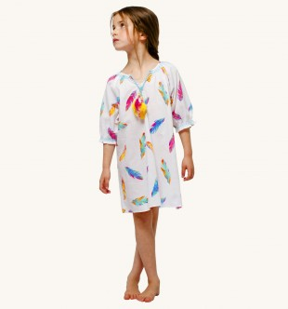 **Colorful Classical Feathers Half Sleeve Shirt**

**Materials, Care & Information:**

* 79% Cotton, 18% nylon, 3% spandex
* Machine wash at 25 degrees

## Description:

* The sexy elongated white shirt with colorful frequency division classical feathers represented a mature kids feeling.
* This summer style seem comfortable and suitable under the sunshine and soft sandy which beside the beach.

## Cost: SGD 45.90

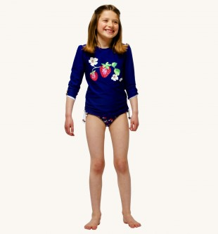**Cutie-berry and Floral Half Sleeve Shirt**

**Materials, Care & Information:**

* Machine Washable
* 80% Nylon, 20% Elastane
* Keep away from fire

## Description:

* A pretty and practical choice, this cute strawberry from the farm enthusiasts Babeskin is ideal for seaside or pool trips.
* The chlorine resistant half sleeve shirt comes in a pretty floral print beside the cutie-berry.
* It's quick drying and designed to retain its shape after swimming.

## Cost: SGD 45.90

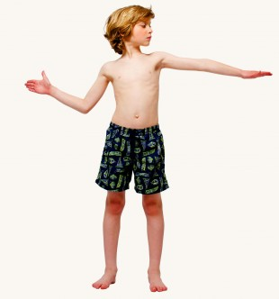

**Vivid Aquatic Summer Style Strunks**

**Materials, Care & Information:**

* Shorts: 100% Polyamide
* Mesh Lining: 50% Cotton and 50% Polyester
* Machine washable 30 degrees

## Description:

* From FRIAS, these navy swimming trunks feature a fun neon print of toucans and tropical vivid aquatic in green.
* An elasticated drawstring waist and velcro fastening pocket to the back for any treasures found at the beach.
* They also come with a waterproof, drawstring bag for easy transportation to and from the beach or poolside.

## Cost: SGD 49.90

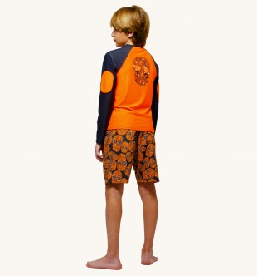

**Perky Skull Stated Rear Side**

**Materials, Care & Information:**

* Machine Washable
* 80% Nylon, 20% Elastane
* Keep away from fire

## Description:

* With a protective rash vest and matching swimming shorts, this Perky Skull set is a practical choice for keen little swimmers.
* The color dramatically contrast used at the shoulders and elbows adds quirtiness.
* The rash vest has a high UPF 50+ rating, contrasting sleeves and Perky Skull logo.
* Top pulls on with short sleeves and high neck

**Cost: SGD 49.90**

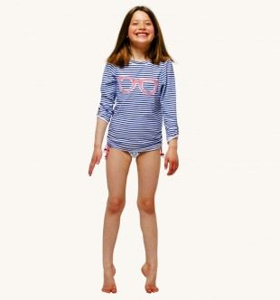

**Rose Sunglasses on Striped Design Shirt**

**Materials, Care & Information:**

* Machine Washable
* Outer: 80% Nylon, 20% Elastane. Lining: 100% Polyester
* Keep away from fire

## Description:

* Get ready to make a splash in this Rose Sunglasses.
* The long sleeves features blue and white horizontal narrow stripes with a classical rose sunglasses.

**Cost: SGD 39.90**

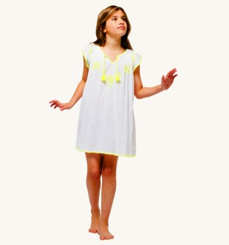**Treat Dreams of Innocent Kids Dress**

**Materials, Care & Information:**

* Machine Washable
* 100% Cotton
* Keep away from fire

## Description:

* The hairy hairballs are gracefully suspended at both ends of the collar.
* The sharply liner with different interactive color options are available depends on your taste.
* They also come with a soft, drawstring bag for easy transportation to and from the beach or poolside.

**Cost: SGD 39.90**

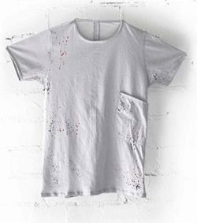**Classical T-shirt Belongs to the Beach**

**Materials, Care & Information:**

* Machine Washable
* 100% Cotton
* Keep away from fire

## Description:

* The classical T-shirt which is belonging to the beautiful beach.
* Side pocket on the left hand side represented a casual character, which highlights at the beach to enjoy the atmosphere.

**Cost: SGD 25.90**